Copy C:\Users\nguye\Downloads\03-10-2023-06-38-31-layoutcrm(update)\LayoutCrm into C:\Users\nguye\java_course_demo\Tomcat_web\Tomcat_web\src\main\webapp

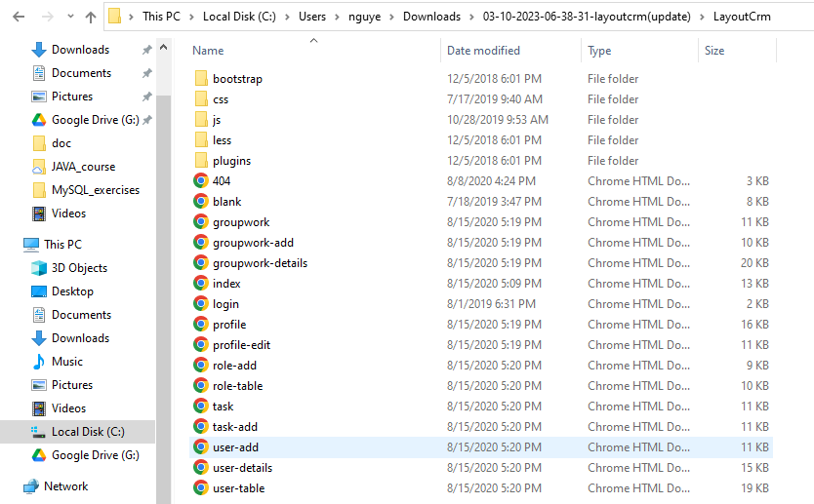

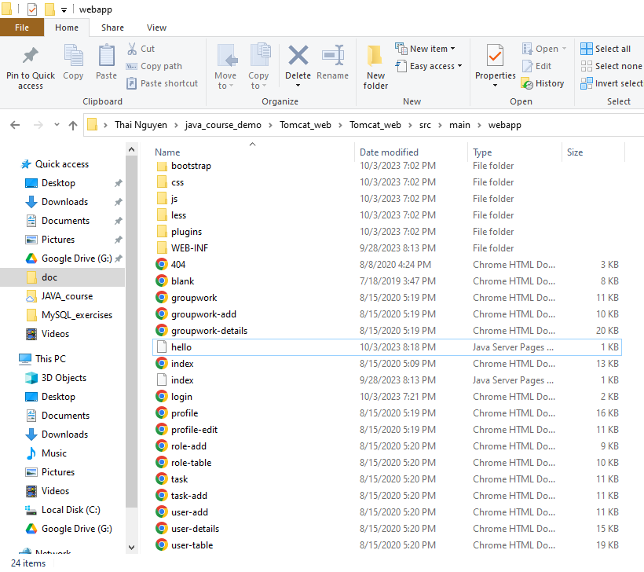

Sau đó vào Tomcat_web\Tomcat_web\src\main\java, tạo class mới.

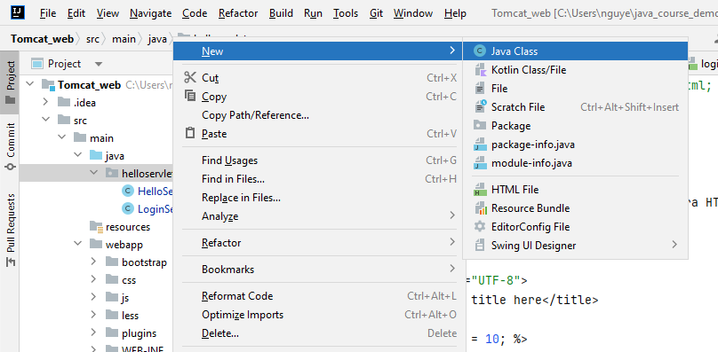

VD: đặt tên class là LoginServlet

package helloservlet;  
  
import java.io.IOException;  
  
import javax.servlet.ServletException;  
import javax.servlet.annotation.WebServlet;  
import javax.servlet.http.HttpServlet;  
import javax.servlet.http.HttpServletRequest;  
import javax.servlet.http.HttpServletResponse;  
  
@WebServlet(name = "loginServlet", urlPatterns = {"/login"})  
public class LoginServlet extends HttpServlet {  
 *// GET, POST => Methods cách thức HTTP client gọi đường dẫn* @Override  
 protected void doGet(HttpServletRequest req, HttpServletResponse resp) throws ServletException, IOException {  
 *// TODO Auto-generated method stub  
// super.doGet(req, resp);  
 //Hiển thị nọi dug file html khi người dùng gọi link/login* req.getRequestDispatcher("login.html").forward(req, resp);  
 }  
  
 @Override  
 protected void doPost(HttpServletRequest req, HttpServletResponse resp) throws ServletException, IOException {  
 *// TODO Auto-generated method stub* String email = req.getParameter("email");  
 String password = req.getParameter("password");  
 System.*out*.println("Debug POST: email = " + email);  
 System.*out*.println("Debug POST: password = " + password);  
 req.getRequestDispatcher("login.html").forward(req, resp);  
 }  
}

protected void doGet(HttpServletRequest req, HttpServletResponse resp) throws ServletException, IOException {  
 *// Sẽ thực hiện khi người dùng query đường dẫn* PrintWriter printwriter = resp.getWriter();  
 printwriter.write("Hello Servlet world");  
 printwriter.close();  
 *// Lấy giá trị của tham số có tên là username và age* String username = req.getParameter("username");  
*// int age = Integer.parseInt(req.getParameter("age"));  
// System.out.println("Debug: username = "+ username);  
// System.out.println("Debug: age = "+ age);* req.getRequestDispatcher("hello.jsp").forward(req, resp);  
 }

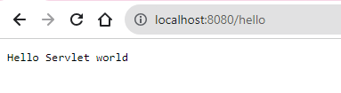

Do printwriter.close() close connection nên những dòng sau sẽ không được thực thi

<https://vi.wikipedia.org/wiki/JSP>